Changes in Marysville TNR Program

Due to COVID-19
Trapping Effective: 3/20/20
We are halting all trapping effective immediately unless it is an urgent situation. Examples of an urgent situation include:
- An injured or acutely ill cat that is not able to be handled.
- A litter of neonate kittens whose mother is feral. The kittens can be used to bait the trap to secure the mother.
Please contact FieldHaven at 530-686-CATS (2287) or Animal Care Services at 530-749-3900 for assistance with urgent situations.
Colony Feeding
Feeding of feral colonies is allowed with prior approval. Please register with FieldHaven to indicate which colonies you are feeding. The registration form is here: https://form.jotform.com/200796829459169
We have a supply of food for colony caregivers. To make arrangements to pickup food email jeanie@fieldhaven.com or audra@fieldhaven.com. To get food, your colonies must be registered.
Pregnant Cats
If an obviously pregnant cat is found and is friendly call FieldHaven at 530-686-CATS (2287). If the cat is feral please leave the cat to have her kittens in the field then we will secure them.
Kittens
We are expecting the kitten storm to come at any time. For any of the following situations contact FieldHaven by calling 530-686-CATS (2287) or Animal Care Services at 530-749-3900 M-F. Or you can post on the Marysville Cat Squad page on Facebook: (https://www.facebook.com/groups/TNRSquad/ - you will need to join).
- You find a litter of kittens with no mother.
  - Are they old enough to eat on their own?
    - Yes - can you foster them for a short term until we can arrange transport?
    - No – please contact FieldHaven as soon as possible.
- You find a litter of kittens with a mother
  - If mom is friendly can you foster them for a short term until we can arrange transport?
  - If mom is feral, leave kittens where they are (if safe), put out food and water for mom then contact FieldHaven.
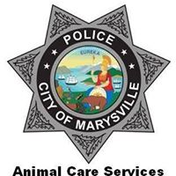
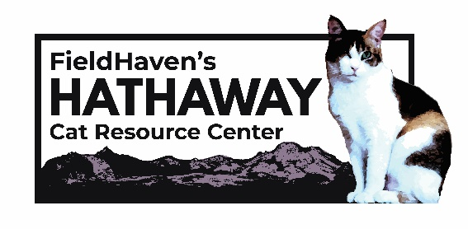
Marysville Animal Care Services
530-749-3300
facebook.com/marysvilleACS
FieldHaven’s Hathaway Cat Resource Center
530-686-CATS (2287)
marysville@fieldhaven.com
fieldhaven.com/marysville

